LIBRARY MANAGEMENT SYSTEM
A DBMS Capstone Project Report submitted in partial fulfillment of the requirements for the award of the degree of
BACHELOR OF TECHNOLOGY
in
ARTIFICIAL INTELLIGENCE AND MACHINE LEARNING

Submitted By
B. SAI AKSHATH – 25B11AI151
B. LIKHITHA – 25B11AI097
R. SUPRIYA – 25B11AIA30
K. JAHNAVI – 25B11AI471

Under the esteemed guidance of
Mr. T.Srinivasulu M.Tech, (Ph.D.)
Assistant Professor


DEPARTMENT OF ARTIFICIAL INTELLIGENCE AND MACHINE LEARNING
ADITYA UNIVERSITY
(Formerly Aditya Engineering College (A))
Aditya Nagar, ADB Road, Surampalem, Andhra Pradesh, India
2026 – 2027

Aditya Nagar, ADB Road, Surampalem, Andhra Pradesh, India
DEPARTMENT OF ARTIFICIAL INTELLIGENCE AND MACHINE LEARNING
CERTIFICATE
This is to certify that the DBMS Capstone Project report entitled “LIBRARY MANAGEMENT SYSTEM” is being submitted by B. SAI AKSHATH (Roll No. 25B11AI151), B. LIKHITHA (Roll No. 25B11AI097), R. SUPRIYA (Roll No. 25B11AIA30) and K. JAHNAVI (Roll No. 25B11AI471) in partial fulfillment of the requirements for the award of the B.Tech. degree in Artificial Intelligence and Machine Learning. The work documented in this report was carried out as part of the Capstone Project for the course Database Management Systems (2501IT05) during the academic year 2026–2027, and records the database design, implementation, and documentation undertaken by the team.

Project Guide Head of the Department
Mr. T. Srinivasulu, M. Tech, (Ph.D.) Dr. K. Naga Bhargavi, M. Tech, Ph.D. Associate professor Associate Professor & HOD

External Examiner

DECLARATION
We hereby declare that the DBMS Capstone Project entitled “LIBRARY MANAGEMENT SYSTEM” is a genuine work carried out by us. The database design, SQL implementation, queries and documentation presented in this report are our own work, completed under the guidance of Mr. T. SRINIVASULU, Department of AIML, Aditya University, Surampalem. We further declare that this work has not been submitted, in full or in part, for the award of any degree of this or any other educational institution.

Project Associates
B. SAI AKSHATH (25B11AI151)
B. LIKHITHA (25B11AI097)
R. SUPRIYA (25B11AIA30)
K. JAHNAVI (25B11AI471)

Date: 28-09-2026
Place: Surampalem

ACKNOWLEDGEMENT
It is with immense pleasure that we express our indebted gratitude to our project guide Mr. T. Srinivasulu, Department of AIML, who guided us throughout the capstone project. We are thankful for the constant encouragement and valuable suggestions received at every review stage.
We are grateful to Dr. K. Naga Bhargavi, Head of the Department, for inspiring us and for arranging the facilities and resources needed for this project.
We extend our sincere thanks to the Management, Dr. M. Sreenivasa Reddy, Deputy Pro-Chancellor, Dr. M. B. Srinivas, Vice-Chancellor, and Dr. A. Ramesh, Pro Vice-Chancellor (Engineering & Sciences), for providing an excellent academic environment.
Not to forget, we thank the Teaching and Non-Teaching Staff, our parents and our friends, who have directly or indirectly supported us in completing this project on time.

Project Associates
B. SAI AKSHATH - 25B11AI151
B. LIKHITHA - 25B11AI097
R. SUPRIYA - 25B11AIA30
K. JAHNAVI - 25B11AI471

ABSTRACT
The Library Management System is a relational database designed to manage books, authors, publishers, members, book loans, and fines in a library. The system stores important information such as book details, ISBN numbers, total copies, authors, publishers, member details, loan dates, due dates, return dates, and fine information. The database reduces data redundancy and provides proper relationships between different entities. The system identifies Book, Author, Publisher, Member, Loan, and Fine as the major entities. The many-to-many relationship between books and authors is resolved using the Book_Author table, while the borrowing relationship between members and books is managed through the Loan table. Primary keys, foreign keys, UNIQUE, NOT NULL, CHECK, and DEFAULT constraints are used to maintain data integrity. Derived information such as available copies and overdue days is calculated rather than unnecessarily stored. The database is normalized up to Third Normal Form to reduce redundancy and update anomalies. The system provides a structured way to manage library records and supports accurate tracking of books, members, loans, and fines.

INDEX
Chapter | Title | Page No.
 | Certificate | 2
 | Declaration | 3
 | Acknowledgement | 4
 | Abstract | 5
 | List of Figures | 8
 | List of Tables | 8
1 | Introduction | 8
 | 1.1 Introduction to the Domain | 8
 | 1.2 Problem Statement | 8
 | 1.3 Motivation and Need for a Database | 8
 | 1.4 Objectives of the Project | 9
 | 1.5 Scope of the Project | 9
 | 1.6 Organization of the Report | 9
2 | System Study and Tools | 10
 | 2.1 Existing System and Its Limitations | 10
 | 2.2 Proposed Database System | 10
 | 2.3 Tools and Technologies Used | 10
 | 2.4 Software and Hardware Requirements | 11
3 | Database Design (Review – I) | 11
 | 3.1 Identified Entities | 11
 | 3.2 Entity Attributes and Attribute Types | 12
 | 3.3 ER Diagram | 13
 | 3.4 Relationships and Cardinality | 13
 | 3.5 Relational Database Schema | 14
 | 3.6 Primary Keys and Foreign Keys | 16
 | 3.7 Normalization up to 3NF | 16
4 | Database Implementation (Review – II) | 17
 | 4.1 Database and Table Creation – DDL | 17
 | 4.2 Sample Data Insertion – DML | 19
 | 4.3 Constraints and Data Integrity | 19
 | 4.4 Data Validation Rules | 20
5 | SQL Operations and Queries | 21
 | 5.1 DQL – Basic Retrieval Queries | 21
 | 5.2 Join Operations | 21
 | 5.3 Aggregate Functions, GROUP BY and HAVING | 22
 | 5.4 Nested and Correlated Subqueries | 22
 | 5.5 Views and Relational Set Operations | 22
 | 5.6 DCL and TCL Operations | 23
6 | Modules and Functionalities | 24
7 | Results – Sample Outputs and Screenshots | 25
8 | Testing and Data Validation | 26
9 | GitHub Repository and Team Contribution | 26
10 | Conclusion and Future Enhancements | 28
 | References | 28
 | Appendix A – Complete SQL Script | 29

LIST OF FIGURES
Figure No. | Title of the Figure | Page No.
Fig. 3.1 | ER Diagram of the Library Management System | 13
Fig. 3.2 | Relational Schema Diagram | 16
Fig. 4.1 | Successful Creation of Tables | 19
Fig. 4.2 | Sample Data Inserted into the Tables | 19
Fig. 4.3 | Referential Integrity Enforced by the Database | 20
Fig. 7.1 | (screenshot to be inserted) | 25
Fig. 7.2 | (screenshot to be inserted) | 25
Fig. 7.3 | (screenshot to be inserted) | 25
Fig. 7.4 | (screenshot to be inserted) | 25

LIST OF TABLES
Table No. | Title of the Table | Page No.
Table 2.1 | Tools and Technologies Used | 10
Table 2.2 | Software and Hardware Requirements | 11
Table 3.1 | Entities Identified for the Selected Domain | 11
Table 3.2 | Attributes of Each Entity | 12
Table 3.3 | Relationships and Cardinality | 13
Table 3.4 | Relational Database Schema | 14
Table 3.5 | Primary Key and Foreign Key Definitions | 16
Table 3.6 | Normalization Steps | 17
Table 4.1 | Sample Data Summary | 19
Table 4.2 | Constraints and Data Integrity Rules | 19
Table 5.1 | Basic Retrieval Queries | 21
Table 5.2 | Join Operations | 21
Table 5.3 | Aggregate, GROUP BY and HAVING Queries | 22
Table 5.4 | Subqueries | 22
Table 5.5 | Views and Set Operations | 22
Table 5.6 | DCL and TCL Operations | 23
Table 6.1 | Modules and Their Functionalities | 24
Table 8.1 | Test Cases and Results | 26
Table 9.1 | Team Responsibilities | 26
Table 9.2 | Review-wise Progress Record | 27

CHAPTER 1: INTRODUCTION

1.1 Introduction to the Domain
A Library Management System is a database-based system designed to manage and organize information related to books, authors, publishers, members, book loans, and fines. The system helps maintain library records efficiently and reduces the difficulties involved in managing library information manually.
The system stores details about available books, their authors and publishers, registered members, book issue and return details, and fines associated with overdue books. By using a relational database, the information can be stored in a structured manner and retrieved whenever required.
The Library Management System uses entities such as Book, Author, Publisher, Member, Loan, and Fine. These entities are connected through relationships to maintain consistency and referential integrity in the database.

1.2 Problem Statement

Managing library records manually can become difficult when the number of books and members increases. It may be challenging to keep track of:

Book details and available copies

Authors and publishers

Member information

Books issued to members

Due dates and return dates

Overdue books

Fines and their payment status

Therefore, a structured database system is required to store and manage library information efficiently while maintaining data accuracy and consistency.

1.3 Motivation and Need for a Database
A manual or spreadsheet-based system can store library records, but it becomes difficult to maintain
relationships between books, authors, publishers, members, loans, and fines as the amount of data increases. It may allow duplicate book or member records, incorrect loan information, or records referring to books or members that no longer exist. A database management system helps prevent such problems by using PRIMARY KEY, UNIQUE, CHECK, NOT NULL and FOREIGN KEY constraints to maintain accurate and consistent data. It also provides a structured way to store and retrieve library information using SQL queries. The database makes it easier to track book loans, due dates, return dates, and fines while maintaining relationships between the different entities. Therefore, a relational database is needed to organize the library data efficiently, reduce data redundancy through normalization, maintain data integrity, and provide reliable access to the required information.

1.4 Objectives of the Project
1. To maintain details of books available in the library.
2. To store information about authors and publishers.
3. To maintain member information.
4. To record book loan and return details.
5. To manage fines for overdue loans.

1.5 Scope of the Project
The database covers the major operations of a library, including books, authors, publishers, members, loans and fines. It maintains book details such as title, ISBN, number of copies, genre and publication year, along with the authors and publishers associated with each book. It also stores member information and records the issue and return of books through the Loan table, including loan dates, due dates, return dates and status. Fine details are maintained for overdue loans along with their payment status. The database supports relationships between these entities and uses normalization, primary keys, foreign keys and other constraints to maintain data integrity.
The following are outside the scope of the present work: a graphical front-end application, online payment processing, digital book management, automated notifications, and advanced reservation functionality. The project mainly focuses on database design and implementation, and the library information is managed through SQL operations and queries.

1.6 Organization of the Report
This report is organized into ten chapters. Chapter 2 presents the system study and the tools used for developing the Library Management System. Chapter 3 covers the complete database design, including the entities, attributes, ER diagram, relationships, relational schema and normalization. Chapter 4 describes the database implementation using DDL commands, table creation and sample data. Chapter 5 presents the SQL operations and queries used to retrieve and manipulate library information. Chapter 6 explains the modules and functionalities of the system. Chapter 7 presents the sample outputs and results obtained from the database queries. Chapter 8 covers testing and data validation of the database constraints and relationships. Chapter 9 details the GitHub repository and the contribution of each team member. Chapter 10 concludes the report and describes the limitations and possible future enhancements of the Library Management System.

CHAPTER 2: SYSTEM STUDY AND TOOLS

2.1 Existing System and Its Limitations
In a traditional library, book and member information may be maintained using registers, spreadsheets or separate files. As the number of books and members increases, maintaining these records manually becomes difficult. Book details, author information, publisher details, member records and loan information may be stored separately, making it difficult to maintain relationships between them.
The following limitations can occur in a manual or file-based system:
- The same book or member information may be entered repeatedly.
- It is difficult to track which member has borrowed a particular book.
- Due dates and return dates have to be checked manually.
- Overdue books and fines may not be tracked accurately.
- Duplicate ISBN or member email records may be entered.
- Maintaining relationships between books, authors and publishers is difficult.
- Searching for particular library information requires manual effort.
- Updating records in multiple files may result in inconsistent information.
The proposed database system addresses these limitations by storing the information in related tables and enforcing relationships using primary keys and foreign keys.

2.2 Proposed Database System
The proposed Library Management System is a relational database that stores library information in a structured manner. The system contains six main entities: Book, Author, Publisher, Member, Loan and Fine. A separate Book_Author table is used to represent the many-to-many relationship between books and authors.
The Book table stores information such as title, ISBN, number of copies, genre, publication year and publisher. The Author and Publisher tables maintain information about the people who write books and the organizations that publish them. The Member table stores details of library members, while the Loan table records book borrowing and return information.
The Fine table stores fine information related to overdue loans. Primary keys uniquely identify records and foreign keys maintain relationships between the tables. UNIQUE, NOT NULL, CHECK and DEFAULT constraints are used where required to maintain data integrity.

2.3 Tools and Technologies Used
Table 2.1: Tools and Technologies Used
Category | Tool / Technology Used | Version / Remarks
Database Server | MySQL | 8.0 — relational DBMS used for implementation
Query / Admin Tool | MySQL Workbench | 8.0 CE — SQL script execution and output
Online SQL Practice | dbfiddle.dev | Used to verify SQL queries independently
ER Diagram Tool | draw.io (diagrams.net) | Web version — ER and schema diagrams
Version Control | Git and GitHub | Team repository for the SQL script
Documentation | Microsoft Word | Report preparation

2.4 Software and Hardware Requirements
Table 2.2: Software and Hardware Requirements
Requirement Type | Specification
Operating System | Windows 10 / 11 (64-bit) or Ubuntu 22.04
Database Server | MySQL 8.0 or above
Client Tool | MySQL Workbench 8.0 CE / MySQL command-line client
Processor | Intel Core i3 or above
RAM | 4 GB or above
Disk Space | Minimum 10 GB free space

CHAPTER 3: DATABASE DESIGN
(Deliverables of Review – I)

3.1 Identified Entities
Six core entities were identified from the study of the library management domain, representing books, authors, publishers, members, loans, and fines.
Table 3.1: Entities Identified for the Selected Domain
S.No | Entity Name | Description
1 | Book | Stores information about books available in the library.
2 | Author | Stores details of authors who write the books.
3 | Publisher | Stores information about publishers of the books.
4 | Member | Stores details of library members.
5 | Loan | Records books issued to members and their return details.
6 | Fine | Stores fine details associated with overdue loans.

3.2 Entity Attributes and Attribute Types
Every attribute of every entity, along with its data type, key role and attribute type, is listed in Table 3.2. Primary-key attributes are marked PK and foreign-key attributes FK; all other attributes are simple, single-valued attributes.
Table 3.2: Attributes of Each Entity
Entity | Attribute | Data Type | Key (PK / FK / —) | Attribute Type
Book | book_id | INT | PK | Simple
Book | title | VARCHAR(200) | NOT NULL | Simple
Book | isbn | VARCHAR(20) | UNIQUE,NOT NULL | Simple
Book | total_copies | INT | DEFAULT 1 | Simple
Book | available_copies | INT | - | Derived
Book | genre | VARCHAR(50) | - | Simple
Book | publication_year | YEAR | - | Simple
Book | authors | TEXT | - | Multi-valued
Author | author_id | INT | PK | Simple
Author | first_name | VARCHAR(50) | - | Composite
Author | last_name | VARCHAR(50) | - | Composite
Author | nationality | VARCHAR(50) | - | Simple
Publisher | publisher_id | INT | PK | Simple
Publisher | publisher_name | VARCHAR(100) | NOT NULL | Simple
Publisher | country | VARCHAR(50) | - | Simple
Publisher | website | VARCHAR(200) | - | Simple
Member | member_id | INT | PK | Simple
Member | first_name | VARCHAR(50) | NOT NULL | Composite
Member | last_name | VARCHAR(50) | NOT NULL | Composite
Member | email | VARCHAR(100) | UNIQUE | Simple
Member | membership_type | VARCHAR(30) | - | Simple
Member | membership_date | DATE | - | Simple
Member | membership_expiry | DATE | - | Simple
Member | phone_numbers | TEXT | - | Multi-valued
Loan | loan_id | INT | PK | Simple
Loan | book_id | INT | FK, NOT NULL | Simple
Loan | member_id | INT | FK, NOT NULL | Simple
Loan | loan_date | DATE | FK, NOT NULL | Simple
Loan | due_date | DATE | FK, NOT NULL | Simple
Loan | return_date | DATE | - | Simple
Loan | Days_overdue | INT | - | Derived
Loan | status | VARCHAR(20) | Default “Active” | Simple
Fine | fine_id | INT | PK | Simple
Fine | loan_id | INT | FK,UNIQUE,NOT NULL | Simple
Fine | member_id | INT | FK,NOT NULL | Simple
Fine | fine_amount | DECIMAL(8,2) | CHECK>=0 | Simple
Fine | fine_date | DATE | - | Simple
Fine | payment_status | VARCHAR(20) | DEFAULT “Unpaid” | Simple

3.3 ER Diagram
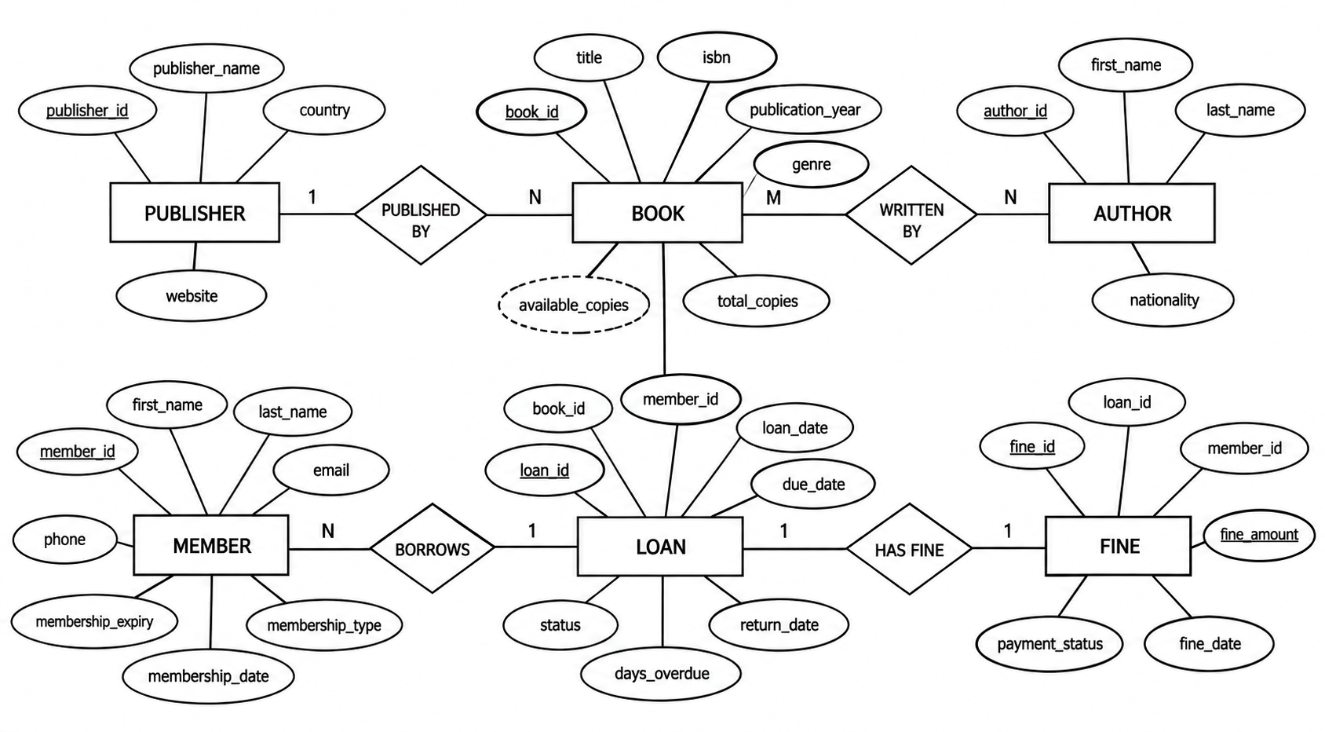

The ER diagram for the Library Management System was drawn in draw.io and is shown in Fig. 3.1. All six entities are shown as rectangles and their attributes as ellipses, with primary-key attributes underlined. The M:N relationship between Book and Author is resolved through the Book_Author junction entity.
Fig. 3.1: ER Diagram of the Library Management System

3.4 Relationships and Cardinality
The relationships identified between the entities, together with their cardinality and participation, are summarised in Table 3.3.
Table 3.3: Relationships and Cardinality
Entity 1 | Relationship | Entity 2 | Cardinality (1:1 / 1:N / M:N) | Participation
Book | Written By | Author | M | Partial on Book
Book | Published By | Publisher | M:1 | Total on Book
Member | Borrows through loan | Book | M | Partial on Member
Loan | Generates | Fine | 1:1 | Partial on Loan
Member | Has | Fine | 1 | Partial on Fine

3.5 Relational Database Schema
The ER diagram was converted into relations using the standard mapping rules: each entity became a table, the M:N relationship between Book and Author was mapped to the Book_Author junction table with a composite primary key, and 1:N relationships were mapped with foreign keys on the many side. Table 3.4 lists every table with its columns, data types and constraints.
Table 3.4: Relational Database Schema
Table Name | Column Name | Data Type | Key (PK / FK / —) | Constraints
Publisher | publisher_id | INT | PK | AUTO_INCREMENT
Publisher | publisher_name | VARCHAR(100) | - | NOT NULL
Publisher | country | VARCHAR(50) | - | -
Publisher | website | VARCHAR(200) | - | -
Book | book_id | INT | PK | AUTO_INCREMENT
Book | title | VARCHAR(200) | - | NOT NULL
Book | isbn | VARCHAR(20) | - | UNIQUE, NOT NULL
Book | total_copies | INT | - | DEFAULT 1
Book | genre | VARCHAR(50) | - | -
Book | publication_year | YEAR | - | -
Book | publisher_id | INT | FK | REFERENCES Publisher
Author | author_id | INT | PK | AUTO_INCREMENT
Author | first_name | VARCHAR(50) | - | -
Author | last_name | VARCHAR(50) | - | -
Author | nationality | VARCHAR(50) | - | -
Book_Author | book_id | INT |  | REFERENCES Book
  PK, FK
Book_Author | author_id | INT |  | REFERENCES Author
  PK, FK
Member | member_id | INT | PK | AUTO_INCREMENT
Member | first_name | VARCHAR(50) | - | NOT NULL
Member | last_name | VARCHAR(50) | - | NOT NULL
Member | email | VARCHAR(100) | - | UNIQUE
Member | membership_type | VARCHAR(30) | - | -
Member | membership_date | DATE | - | -
Member | membership_expiry | DATE | - | -
Loan | loan_id | INT | PK | AUTO_INCREMENT
Loan | book_id | INT | FK | NOT NULL, References Book
Loan | member_id | INT | FK | NOT NULL, REFERENCES Member
Loan | loan_date | DATE | - | NOT NULL
Loan | due_date | DATE | - | NOT NULL
Loan | return_date | DATE | - | -
Loan | status | VARCHAR(20) | - | DEFAULT “Active”
Fine | fine_id | INT | PK | AUTO_INCREMENT
Fine | loan_id | INT | FK | UNIQUE, NOT NULL, REFERENCES Loan
Fine | member_id | INT | FK | NOT NULL, REFERENCES Member
Fine | fine_amount | DECIMAL(8,2) | - | CHECK (fine_amount >= 0)
Fine | fine_date | DATE | - | -
Fine | payment_status | VARCHAR(20) | - | DEFAULT "Unpaid"

Schema Diagram
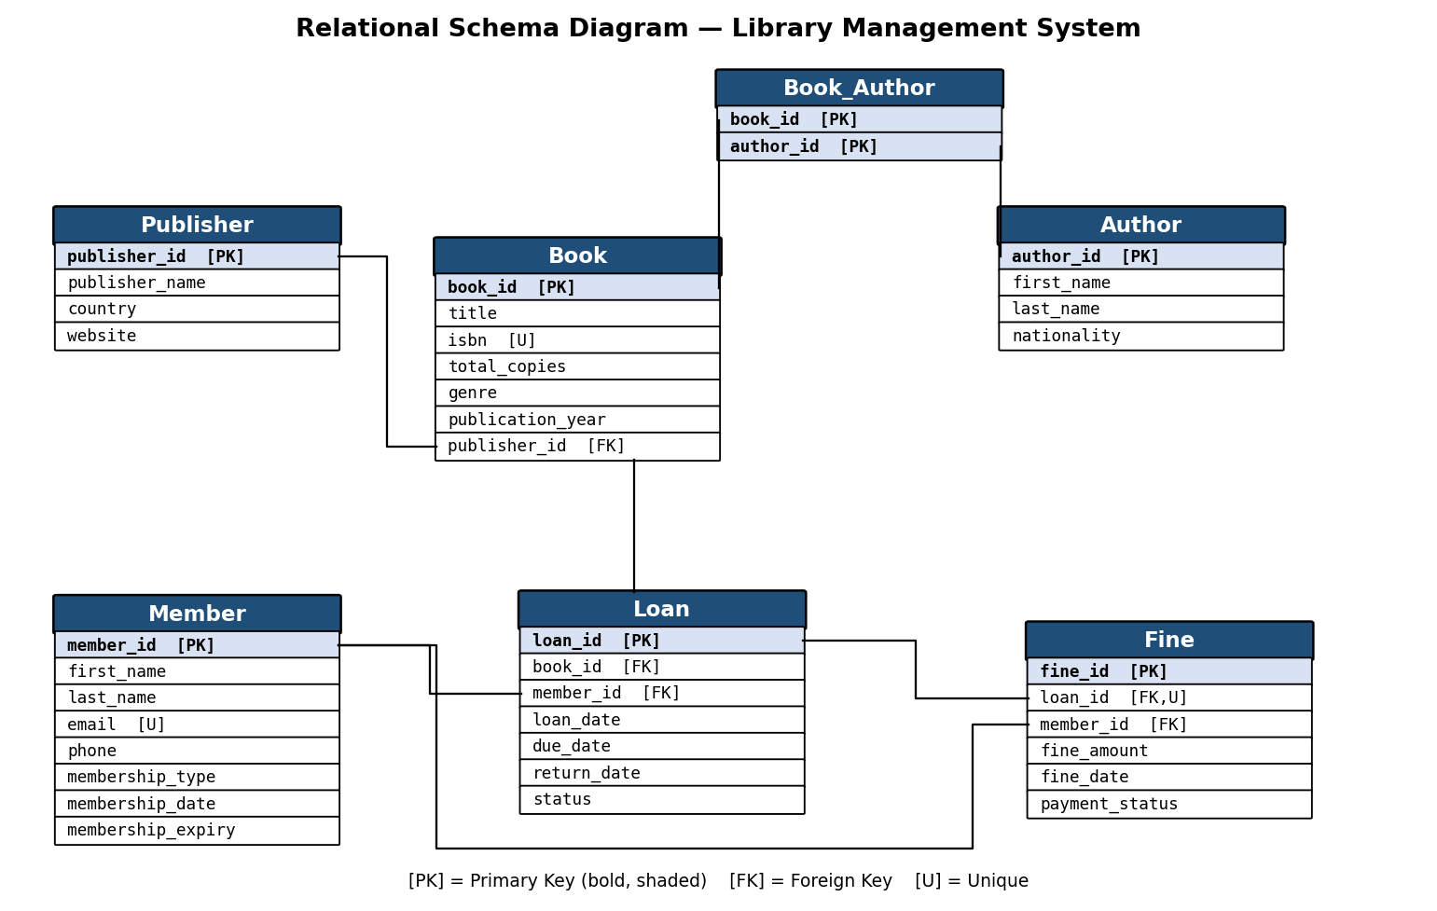
Fig. 3.2: Relational Schema Diagram

3.6 Primary Keys and Foreign Keys
Primary keys uniquely identify each row, and foreign keys enforce the relationships between tables. Table 3.5 lists the primary key and foreign keys of every table.
Table 3.5: Primary Key and Foreign Key Definitions
Table | Primary Key | Foreign Key | References (Table.Column)
Publisher | publisher_id | - | -
Book | book_id | publisher_id
  Publisher(publisher_id)
Author | author_id | - | -
Book_Author | book_id,author_id | book_id, author_id | Book(book_id), Author(author_id)
Member | member_id | - | -
Loan | loan_id | book_id, member_id | Book(book_id), Member(member_id)
Fine | fine_id | loan_id, | Loan(loan_id), Member(member_id)

3.7 Normalization up to 3NF
The design was normalised step by step from an unnormalized relation to the third normal form. The functional dependencies considered were: book_id → title, isbn, total_copies, genre, publication_year, publisher_id; author_id → first_name, last_name, nationality; member_id → member details; loan_id → book_id, member_id, loan_date, due_date, return_date, status; fine_id → loan_id, member_id, fine_amount, fine_date, payment_status. Table 3.6 summarises the normalisation steps.
UNF → 1NF → 2NF → 3NF
Table 3.6: Normalization Steps
Normal Form | Condition Satisfied | Anomaly Removed | Resulting Tables
UNF | Flat relation with repeating groups (a book with several authors listed in one row). | Repeating groups, update anomalies | One wide unnormalized relation
1NF | All attributes atomic; multi-valued authors separated into Author with the Book_Author junction. | Repeating groups removed | Publisher, Book, Author, Book_Author, Member, Loan, Fine
2NF | No partial dependency: every non-key attribute depends on the full primary key (the only composite key is Book_Author, whose columns are both key). | Partial dependencies removed | Same 7 tables
3NF | No transitive dependency: fine_amount depends only on fine_id; derived attributes (available_copies, days_overdue) are computed, not stored. | Transitive dependencies and redundancy removed | Same 7 tables — final schema

CHAPTER 4: DATABASE IMPLEMENTATION
(Deliverables of Review – II)

4.1 Database and Table Creation – DDL
The database library_db and all seven tables were created with the DDL script below. Primary keys, foreign keys and UNIQUE, NOT NULL, CHECK and DEFAULT constraints enforce the integrity rules identified during the design.
CREATE DATABASE IF NOT EXISTS library_db;
USE library_db;
-- ---------------- DDL : table creation with constraints ----------------
CREATE TABLE Publisher (
publisher_id INT PRIMARY KEY AUTO_INCREMENT,
publisher_name VARCHAR(100) NOT NULL,
country VARCHAR(50),
website VARCHAR(200)
);
CREATE TABLE Book (
book_id INT PRIMARY KEY AUTO_INCREMENT,
title VARCHAR(200) NOT NULL,
isbn VARCHAR(20) UNIQUE NOT NULL,
total_copies INT DEFAULT 1 CHECK (total_copies >= 0),
genre VARCHAR(50),
publication_year YEAR,
publisher_id INT,
FOREIGN KEY (publisher_id) REFERENCES Publisher(publisher_id)
);
CREATE TABLE Author (
author_id INT PRIMARY KEY AUTO_INCREMENT,
first_name VARCHAR(50),
last_name VARCHAR(50),
nationality VARCHAR(50)
);
CREATE TABLE Book_Author (
book_id INT NOT NULL,
author_id INT NOT NULL,
PRIMARY KEY (book_id, author_id),
FOREIGN KEY (book_id) REFERENCES Book(book_id),
FOREIGN KEY (author_id) REFERENCES Author(author_id)
);
CREATE TABLE Member (
member_id INT PRIMARY KEY AUTO_INCREMENT,
first_name VARCHAR(50) NOT NULL,
last_name VARCHAR(50) NOT NULL,
email VARCHAR(100) UNIQUE,
phone VARCHAR(15),
membership_type VARCHAR(30) DEFAULT 'Student',
membership_date DATE,
membership_expiry DATE
);
CREATE TABLE Loan (
loan_id INT PRIMARY KEY AUTO_INCREMENT,
book_id INT NOT NULL,
member_id INT NOT NULL,
loan_date DATE NOT NULL,
due_date DATE NOT NULL,
return_date DATE,
status VARCHAR(20) DEFAULT 'Active',
FOREIGN KEY (book_id) REFERENCES Book(book_id),
FOREIGN KEY (member_id) REFERENCES Member(member_id)
);
CREATE TABLE Fine (
fine_id INT PRIMARY KEY AUTO_INCREMENT,
loan_id INT UNIQUE NOT NULL,
member_id INT NOT NULL,
fine_amount DECIMAL(8,2) CHECK (fine_amount >= 0),
fine_date DATE,
payment_status VARCHAR(20) DEFAULT 'Unpaid',
FOREIGN KEY (loan_id) REFERENCES Loan(loan_id),
FOREIGN KEY (member_id) REFERENCES Member(member_id)
);
--

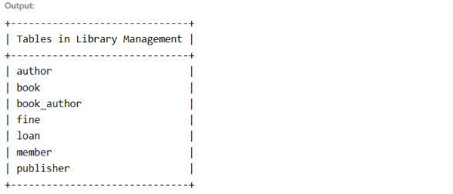

Fig. 4.1: Successful Creation of Tables
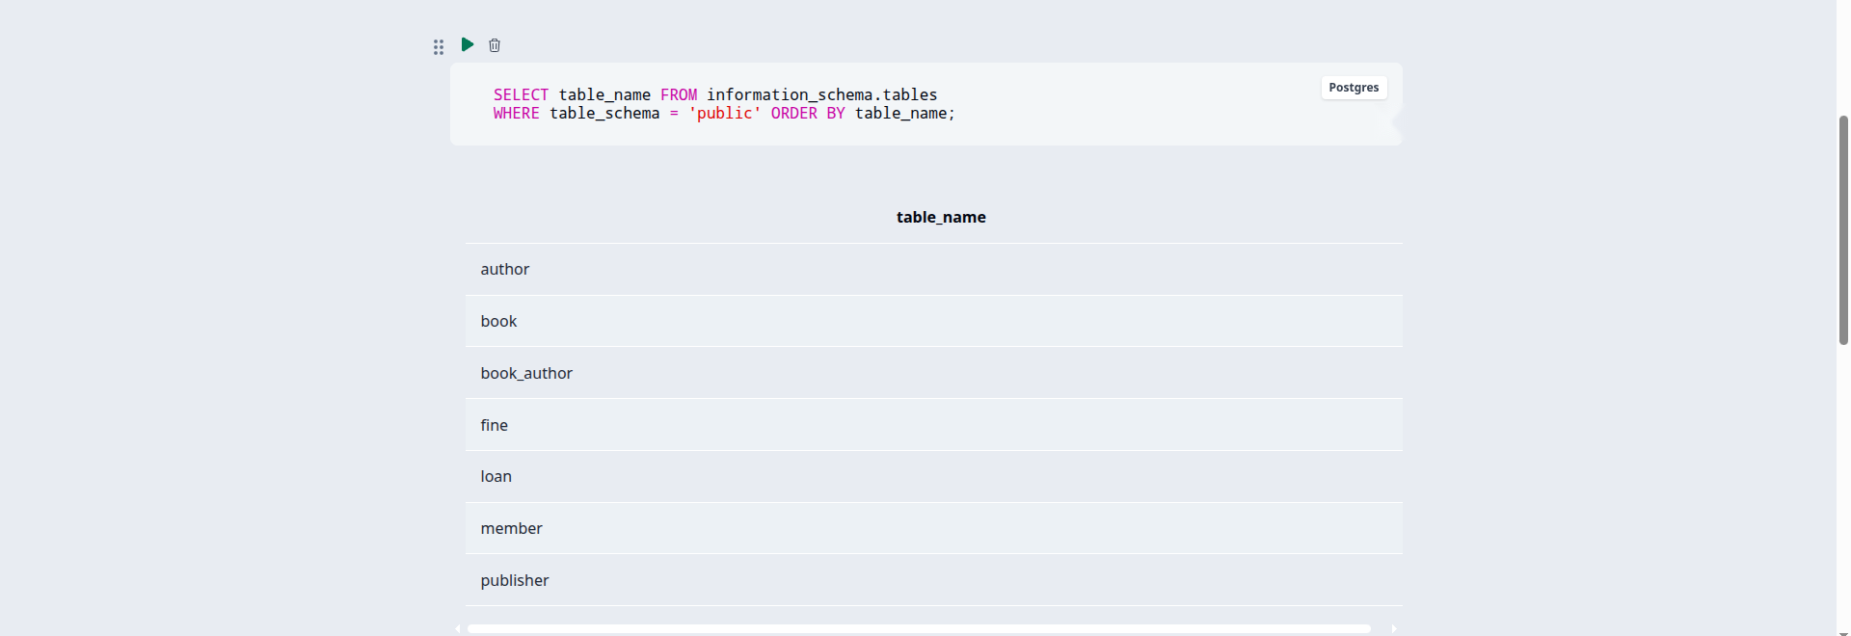

4.2 Sample Data Insertion – DML
Sample data was inserted into every table using INSERT statements: 3 publishers, 3 authors, 3 books with their author mappings, 2 members, 3 loans and 1 fine. UPDATE and DELETE statements were also tested. Table 4.1 summarises the records inserted.
Table 4.1: Sample Data Summary
S.No | Table Name | No. of Records Inserted | Screenshot Reference
1 | Publisher | 3 | Fig. 4.2
2 | Author | 3 | Fig. 4.2
3 | Book | 3 | Fig. 4.2
4 | Book_Author | 3 | Fig. 4.2
5 | Member | 2 | Fig. 4.2
6 | Loan | 3 | Fig. 4.2
7 | Fine | 1 | Fig. 4.2

Fig. 4.2: Sample Data Inserted into the Tables


4.3 Constraints and Data Integrity
The constraints defined on the tables guarantee data integrity, as summarised in Table 4.2.
Table 4.2: Constraints and Data Integrity Rules
Constraint / Validation | Applied On (Table.Column) | Purpose | Evidence / Screenshot Ref.
PRIMARY KEY (AUTO_INCREMENT) | All tables (publisher_id, book_id, author_id, member_id, loan_id, fine_id; composite in Book_Author) | Every row is uniquely identifiable; duplicate IDs are impossible. | TC1, TC2 (§8)
UNIQUE | Book.isbn | No two books can share the same ISBN. | TC1
UNIQUE | Member.email | No two members can share the same email address. | TC2
UNIQUE | Fine.loan_id | At most one fine per loan — enforces the 1:1 Loan–Fine relationship. | TC6
FOREIGN KEY | Book.publisher_id → Publisher.publisher_id | A book must reference an existing publisher. | TC7
FOREIGN KEY | Loan.book_id → Book.book_id, Loan.member_id → Member.member_id | A loan can only be recorded for an existing book and member — no orphan loans. | TC3
FOREIGN KEY | Fine.loan_id → Loan.loan_id, Fine.member_id → Member.member_id | A fine can only be levied on an existing loan and member — no orphan fines. | —
CHECK (fine_amount >= 0) | Fine.fine_amount | A fine can never be negative. | TC4
NOT NULL | Book.title, Member.first_name, Member.last_name, Loan.book_id, Loan.member_id, Loan.loan_date, Loan.due_date, Fine.loan_id, Fine.member_id | Mandatory fields must always have a value. | TC5
DEFAULT | Loan.status = 'Active', Fine.payment_status = 'Unpaid', Member.membership_type = 'Student', Book.total_copies = 1 | Sensible defaults keep data complete even when values are omitted. | §4.2

4.4 Data Validation Rules
Duplicate primary-key values are prevented by AUTO_INCREMENT primary keys, and duplicate ISBNs and member emails are rejected by UNIQUE constraints. CHECK constraints block invalid values such as negative fine amounts, NOT NULL constraints require essential fields, and foreign keys reject orphan records — for example, a loan cannot reference a book that does not exist, as demonstrated in Fig. 4.3.

Fig. 4.3: Referential Integrity Enforced by the Database


CHAPTER 5: SQL OPERATIONS AND QUERIES
Thirty-one queries (Q1–Q31) were executed covering every required category: basic retrieval, joins, aggregate functions, subqueries, views, set operations, DCL and TCL. Each table below gives the query number, its purpose, the SQL statement (MySQL 8.0) and the verified output.

5.1 DQL – Basic Retrieval Queries
Basic SELECT queries with WHERE, ORDER BY and date functions retrieve books, members, loans and fines.
Table 5.1: Basic Retrieval Queries
Q.No | Purpose of the Query | SQL Statement | Output Ref.
Q1 | List all books with their genre and publication year. | SELECT book_id, title, genre, publication_year FROM Book; | 3 rows returned
Q2 | List all registered members. | SELECT member_id, first_name, last_name, email, membership_type FROM Member; | 2 rows returned
Q3 | Show all currently active loans. | SELECT loan_id, book_id, member_id, loan_date, due_date FROM Loan WHERE status = 'Active'; | 1 row (loan_id 2)
Q4 | Show overdue loans (due date passed and not yet returned). | SELECT loan_id, book_id, member_id, due_date FROM Loan WHERE return_date IS NULL AND due_date < CURDATE(); | 1 row (loan_id 2 — overdue)
Q5 | List books of genre 'Technology'. | SELECT title, isbn, total_copies FROM Book WHERE genre = 'Technology'; | 2 rows returned

5.2 Join Operations
Joins combine the catalogue, member, loan and fine data. Q6–Q10 demonstrate inner, left outer and right outer joins; MySQL does not implement FULL OUTER JOIN directly, so Q11 builds it as the UNION of a left and a right join.
Table 5.2: Join Operations
Q.No | Type of Join | SQL Statement | Output Ref.
Q6 | Inner join | SELECT b.title, p.publisher_name, p.country FROM Book b INNER JOIN Publisher p ON b.publisher_id = p.publisher_id; | 3 rows returned
Q7 | Inner join (via junction) | SELECT b.title, CONCAT(a.first_name, ' ', a.last_name) AS author FROM Book b JOIN Book_Author ba ON b.book_id = ba.book_id JOIN Author a ON ba.author_id = a.author_id; | 3 rows returned
Q8 | Inner join (3 tables) | SELECT l.loan_id, CONCAT(m.first_name, ' ', m.last_name) AS member, b.title, l.loan_date, l.due_date, l.status FROM Loan l JOIN Member m ON l.member_id = m.member_id JOIN Book b ON l.book_id = b.book_id; | 3 rows returned
Q9 | Left outer join | SELECT CONCAT(m.first_name, ' ', m.last_name) AS member, f.fine_id, f.fine_amount, f.payment_status FROM Member m LEFT JOIN Fine f ON m.member_id = f.member_id; | 2 rows (Priya Verma → NULLs)
Q10 | Right outer join | SELECT l.loan_id, l.status, f.fine_id, f.fine_amount FROM Fine f RIGHT JOIN Loan l ON f.loan_id = l.loan_id; | 3 rows returned
Q11 | Full outer join (UNION of left + right) | SELECT m.member_id, f.fine_id, f.fine_amount FROM Member m LEFT JOIN Fine f ON m.member_id = f.member_id UNION SELECT m.member_id, f.fine_id, f.fine_amount FROM Member m RIGHT JOIN Fine f ON m.member_id = f.member_id; | 2 rows returned

5.3 Aggregate Functions, GROUP BY and HAVING
Aggregate functions with GROUP BY and HAVING summarise the library data, as shown in Table 5.3.
Table 5.3: Aggregate, GROUP BY and HAVING Queries
Q.No | Function Used | SQL Statement | Output Ref.
Q12 | COUNT(*) | SELECT COUNT(*) AS total_books FROM Book; | 3
Q13 | SUM() + GROUP BY | SELECT member_id, SUM(fine_amount) AS total_fine FROM Fine GROUP BY member_id; | member 1 → 70.00
Q14 | COUNT() + GROUP BY + HAVING | SELECT genre, COUNT(*) AS book_count FROM Book GROUP BY genre HAVING COUNT(*) > 1; | Technology → 2
Q15 | AVG() | SELECT AVG(fine_amount) AS avg_fine FROM Fine; | 70.00
Q16 | MAX() + ORDER BY + LIMIT | SELECT member_id, MAX(fine_amount) AS max_fine FROM Fine GROUP BY member_id ORDER BY max_fine DESC LIMIT 1; | member 1, 70.00

5.4 Nested and Correlated Subqueries
Subqueries place one query inside another. Q17–Q19 use nested subqueries with IN and comparison operators, while Q20–Q22 are correlated subqueries that reference the outer query.
Table 5.4: Subqueries
Q.No | Type (Nested / Correlated) | SQL Statement | Output Ref.
Q17 | Nested | SELECT title FROM Book WHERE book_id NOT IN (SELECT book_id FROM Loan); | 0 rows (every book was loaned at least once)
Q18 | Correlated | SELECT CONCAT(first_name, ' ', last_name) AS member FROM Member m WHERE EXISTS (SELECT 1 FROM Fine f WHERE f.member_id = m.member_id AND f.payment_status = 'Unpaid'); | 1 row (Rahul Sharma)
Q19 | Nested | SELECT title, publication_year FROM Book WHERE publication_year > (SELECT AVG(publication_year) FROM Book); | 2 rows (2019, 2014)
Q20 | Nested | SELECT loan_id, book_id, member_id, status FROM Loan WHERE book_id IN (SELECT book_id FROM Book WHERE total_copies > 3); | 2 rows (loans 1 and 3)
Q21 | Nested | SELECT title, total_copies FROM Book WHERE total_copies > (SELECT AVG(total_copies) FROM Book); | 1 row (Database System Concepts)

5.5 Views and Relational Set Operations
Two views were created: Active_Loans is a simple single-table view and is therefore updatable, while Member_Fine_Summary contains GROUP BY and aggregates and is not updatable. Q26–Q28 demonstrate the set operations UNION, INTERSECT and EXCEPT.
Table 5.5: Views and Set Operations
Q.No | View / Set Operation | SQL Statement | Output Ref.
Q22 | Updatable view | CREATE VIEW Active_Loans AS SELECT loan_id, book_id, member_id, loan_date, due_date FROM Loan WHERE status = 'Active'; | View created (Query OK)
Q23 | Non-updatable view (aggregate) | CREATE VIEW Member_Fine_Summary AS SELECT m.member_id, CONCAT(m.first_name, ' ', m.last_name) AS member, COUNT(f.fine_id) AS fine_count, SUM(f.fine_amount) AS total_fine FROM Member m LEFT JOIN Fine f ON m.member_id = f.member_id GROUP BY m.member_id; | View created (Query OK)
Q24 | UNION | SELECT first_name FROM Author UNION SELECT first_name FROM Member; | 5 rows returned
Q25 | INTERSECT | SELECT first_name FROM Author INTERSECT SELECT first_name FROM Member; | 0 rows (no common first names)
Q26 | EXCEPT (MINUS) | SELECT first_name FROM Author EXCEPT SELECT first_name FROM Member; | 3 rows returned

5.6 DCL and TCL Operations
DCL statements control access to the tables, while TCL statements group changes into atomic transactions with savepoints, as shown in Table 5.6.
Table 5.6: DCL and TCL Operations
Q.No | Command | Purpose | SQL Statement | Output Ref.
Q27 | GRANT | Grant SELECT on Book to the librarian user | GRANT SELECT ON library_db.Book TO 'librarian'@'localhost'; | Query OK (privilege granted)
Q28 | REVOKE | Revoke the SELECT privilege from the librarian user | REVOKE SELECT ON library_db.Book FROM 'librarian'@'localhost'; | Query OK (privilege revoked)
Q29 | COMMIT | Insert a member and permanently save it with COMMIT | START TRANSACTION; INSERT INTO Member (first_name, last_name, email, membership_type) VALUES ('Amit', 'Kumar', 'amit.kumar@example.com', 'Public'); COMMIT; | 1 row inserted and committed
Q30 | SAVEPOINT | Insert two members and mark savepoint sp1 inside the transaction | START TRANSACTION; INSERT INTO Member (first_name, last_name, email, membership_type) VALUES ('Neha', 'Reddy', 'neha.reddy@example.com', 'Student'); SAVEPOINT sp1; INSERT INTO Member (first_name, last_name, email, membership_type) VALUES ('Vikram', 'Rao', 'vikram.rao@example.com', 'Student'); | Savepoint sp1 set
Q31 | ROLLBACK | Roll back to sp1 (undoing the second insert) and COMMIT | ROLLBACK TO sp1; COMMIT; | Rolled back to sp1 and committed (Vikram’s row undone)

CHAPTER 6: MODULES AND FUNCTIONALITIES
The system is organised into seven functional modules. Table 6.1 lists each module, what it does and the tables it operates on.
Table 6.1: Modules and Their Functionalities
S.No | Module Name | Functionality | Tables Involved
1 | Catalogue Management | Add/update books, authors and publishers; link books to authors. | Publisher, Book, Author, Book_Author
2 | Membership Management | Register members, maintain contact and membership details. | Member
3 | Loan / Circulation | Issue books, record due dates, process returns, track active loans. | Loan, Book, Member
4 | Fine Management | Levy fines on overdue loans; track payment status per member. | Fine, Loan, Member
5 | Search & Retrieval | Find books by title, author, genre or publisher; list members and loans. | Book, Author, Publisher, Member, Loan
6 | Reports | Overdue-loan lists, member-wise fine totals, genre statistics. | Loan, Fine, Member, Book
7 | Security & Administration | Access control (GRANT/REVOKE) and transaction control (COMMIT/ROLLBACK). | All tables

Catalogue Management: maintains the library’s stock. Publishers are registered once; each book records its title, ISBN, total copies, genre, publication year and publisher. The UNIQUE constraint on ISBN prevents duplicate catalogue entries.
Author Management: stores author details and links authors to books through the Book_Author junction table, supporting books with multiple authors and authors with multiple books.
Membership Management: registers members with names, a unique email, phone and membership type/dates. The UNIQUE constraint on email prevents duplicate member records.
Loan / Circulation: is the heart of the system. Issuing a book inserts a Loan row with the book, the member, the loan date, the due date and status; returning a book fills in the return date. Foreign keys guarantee that a loan always refers to an existing book and member.
Fine Management: records fines for overdue loans. Each fine links to exactly one loan (UNIQUE on Fine.loan_id) and to the member, with a CHECK constraint ensuring the fine amount is never negative.
Query / Reporting: provides all information needs through SQL — overdue loans, member-wise fine totals, most borrowed books and currently active loans are produced by the queries in Chapter 5.
Administration & Security: the database administrator creates the schema, grants limited privileges to staff accounts with GRANT, revokes them with REVOKE, and groups changes into atomic transactions with COMMIT, SAVEPOINT and ROLLBACK.

CHAPTER 7: RESULTS – SAMPLE OUTPUTS AND SCREENSHOTS
The important execution screenshots are listed below. Each screenshot must clearly show both the query and its output.

Fig. 7.1: Successful Creation of the Database and Tables
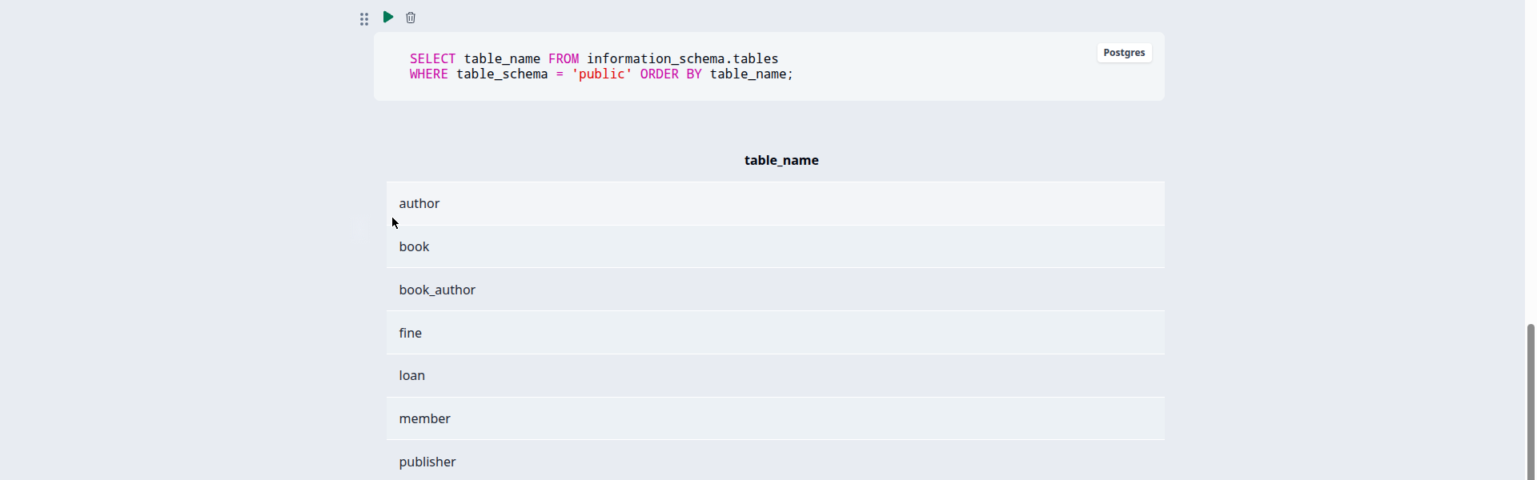

Fig. 7.2: Sample Data in the Book and Loan Tables


Fig. 7.3: Join Query Output — Loan Details with Member and Book (Q8)
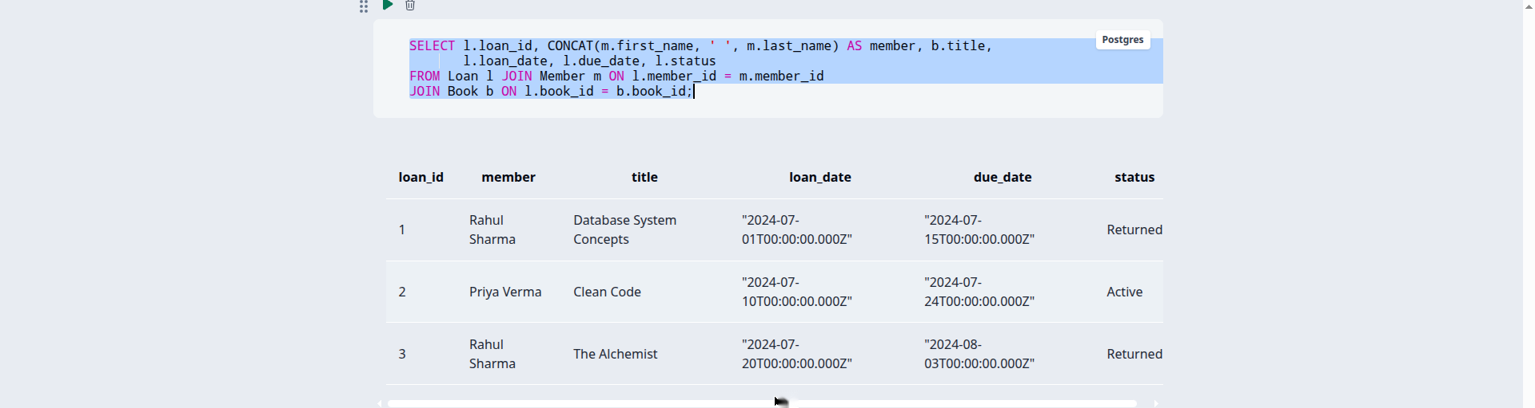

Fig. 7.4: Fine Report — Member-wise Fine Totals (Q13) and Overdue Loans (Q4)


CHAPTER 8: TESTING AND DATA VALIDATION
Nine test cases were executed to verify constraints, referential integrity and query correctness. All test cases passed.
Table 8.1: Test Cases and Results
TC No. | Test Case Description | Input / Action | Expected Result | Actual Result | Status
TC1 | UNIQUE on Book.isbn | INSERT a book with an existing ISBN '978-0073523323'. | Insert rejected with ERROR 1062 (Duplicate entry). | ERROR 1062: Duplicate entry '978-0073523323' for key 'Book.isbn'. | Pass
TC2 | UNIQUE on Member.email | INSERT a member with existing email 'rahul.sharma@example.com'. | Insert rejected with ERROR 1062 (Duplicate entry). | ERROR 1062: Duplicate entry for key 'Member.email'. | Pass
TC3 | FK Loan.book_id → Book | INSERT a loan with book_id = 999 (does not exist). | Insert rejected with ERROR 1452 (foreign key constraint fails). | ERROR 1452: Cannot add or update a child row (Loan_ibfk_1). | Pass
TC4 | CHECK (fine_amount >= 0) | INSERT a fine with fine_amount = -5. | Insert rejected with ERROR 3819 (check constraint violated). | ERROR 3819: Check constraint 'Fine_chk_1' is violated. | Pass
TC5 | NOT NULL on Book.title | INSERT a book with title = NULL. | Insert rejected with ERROR 1048 (column cannot be null). | ERROR 1048: Column 'title' cannot be null. | Pass
TC6 | UNIQUE on Fine.loan_id (1:1) | INSERT a second fine for loan_id = 3. | Insert rejected with ERROR 1062 (Duplicate entry). | ERROR 1062: Duplicate entry '3' for key 'Fine.loan_id'. | Pass
TC7 | FK Book.publisher_id → Publisher | DELETE publisher_id = 1 (still referenced by book 1). | Delete rejected with ERROR 1451 (foreign key constraint fails). | ERROR 1451: Cannot delete a parent row. | Pass
TC8 | Valid loan insertion | INSERT a loan with existing book_id = 1 and member_id = 2. | Row inserted successfully (Query OK). | Query OK, 1 row affected. | Pass
TC9 | Q4 overdue-loan correctness | Run Q4 (overdue loans) against the sample data. | Exactly loan_id 2 returned (due 2024-07-24, not returned). | 1 row returned: loan_id 2. | Pass

CHAPTER 9: GITHUB REPOSITORY AND TEAM CONTRIBUTION

9.1 Repository Details
GitHub Repository Link: https://github.com/Akshathbongi/library-management-system
The final SQL script and all project files were pushed to the team repository on GitHub.

9.2 Team Responsibilities and Contribution
The work was carried out jointly by all four team members; Table 9.1 lists the team.
Table 9.1: Team Responsibilities
S.No | Student Name | Roll Number | Role / Responsibility | Modules Contributed
1 | B. Sai Akshath | 25B11AI151 | Team lead — database design, ER diagram, relational schema | Chapter 3 (design)
2 | B. Likhitha | 25B11AI097 | DDL implementation, constraints, normalization | Chapter 4 (implementation)
3 | R. Supriya | 25B11AIA30 | Sample data, DML/DQL, 31 SQL queries | Chapter 5 (queries)
4 | K. Jahnavi | 25B11AI471 | Testing, validation, documentation and report compilation | Chapters 8–10

9.3 Review-wise Progress
The project was executed in two reviews, as recorded in Table 9.2.
Table 9.2: Review-wise Progress Record
Review | Date | Deliverables Presented | Remarks of the Guide
Review – I | September 2026 | Title, objectives, problem statement; 6 entities + attributes; ER diagram; relational schema; primary/foreign keys; normalization to 3NF. | Presented and approved.
Review – II | September 2026 | Database and 7 tables created with constraints; sample data inserted; DDL/DML/DQL and 31 queries executed; integrity test cases; documentation. | Presented and approved.
Final Review | September 2026 | Complete report with screenshots, test results, GitHub repository and live demonstration. | Presented.

CHAPTER 10: CONCLUSION AND FUTURE ENHANCEMENTS

10.1 Conclusion
The Library Management System database was designed and implemented successfully. Six entities were modelled and implemented as seven tables, with the Book_Author junction table resolving the many-to-many relationship between books and authors. The schema was normalised to the third normal form, sample data covering publishers, books, authors, members, loans and fines was inserted, and thirty-one SQL queries covering DDL, DML, DQL, joins, aggregate functions, subqueries, views, set operations, DCL and TCL were executed and verified. Constraint and referential-integrity test cases confirmed that the database enforces all its integrity rules.

10.2 Limitations of the Present Work
The present work is a database-only implementation with no application front end, so interaction with the system happens through SQL. It does not include online fine payment, book reservation, or automatic overdue notifications; fine amounts are computed through queries rather than generated automatically by the database.

10.3 Future Enhancements
Future enhancements include a web-based front end for librarians and members with login roles, a Reservation module for holding books, automatic fine computation through triggers, stored procedures for book issue and return, and indexing on frequently searched columns such as title and ISBN.

REFERENCES
List textbooks, reference books, documentation and websites referred to. Follow the format shown below.
- Abraham Silberschatz, Henry F. Korth and S. Sudarshan, “Database System Concepts”, 8th Edition, McGraw-Hill, ISBN: 978-1260230508.
- Raghurama Krishnan and Johannes Gehrke, “Database Management Systems”, 4th Edition, McGraw-Hill, ISBN: 978-1260091195.
- Ramez Elmasri and Shamkant B. Navathe, “Fundamentals of Database Systems”, 7th Edition, Pearson, ISBN: 978-0137504277.
- Oracle Corporation, “MySQL 8.0 Reference Manual,” Oracle Documentation. Available at: https://dev.mysql.com/doc/refman/8.0/en/
- MySQL, “MySQL Workbench User Documentation,” Oracle Documentation. Available at: https://dev.mysql.com/doc/workbench/en/

APPENDIX A – COMPLETE SQL SCRIPT
The complete, final SQL script — database creation, DDL, sample data and all 31 queries in execution order — is given below.
-- =====================================================================
-- Library Management System : complete SQL script (MySQL 8.0 dialect)
-- =====================================================================
CREATE DATABASE IF NOT EXISTS library_db;
USE library_db;
-- ---------------- DDL : table creation with constraints ----------------
CREATE TABLE Publisher (
publisher_id INT PRIMARY KEY AUTO_INCREMENT,
publisher_name VARCHAR(100) NOT NULL,
country VARCHAR(50),
website VARCHAR(200)
);
CREATE TABLE Book (
book_id INT PRIMARY KEY AUTO_INCREMENT,
title VARCHAR(200) NOT NULL,
isbn VARCHAR(20) UNIQUE NOT NULL,
total_copies INT DEFAULT 1 CHECK (total_copies >= 0),
genre VARCHAR(50),
publication_year YEAR,
publisher_id INT,
FOREIGN KEY (publisher_id) REFERENCES Publisher(publisher_id)
);
CREATE TABLE Author (
author_id INT PRIMARY KEY AUTO_INCREMENT,
first_name VARCHAR(50),
last_name VARCHAR(50),
nationality VARCHAR(50)
);
CREATE TABLE Book_Author (
book_id INT NOT NULL,
author_id INT NOT NULL,
PRIMARY KEY (book_id, author_id),
FOREIGN KEY (book_id) REFERENCES Book(book_id),
FOREIGN KEY (author_id) REFERENCES Author(author_id)
);
CREATE TABLE Member (
member_id INT PRIMARY KEY AUTO_INCREMENT,
first_name VARCHAR(50) NOT NULL,
last_name VARCHAR(50) NOT NULL,
email VARCHAR(100) UNIQUE,
phone VARCHAR(15),
membership_type VARCHAR(30) DEFAULT 'Student',
membership_date DATE,
membership_expiry DATE
);
CREATE TABLE Loan (
loan_id INT PRIMARY KEY AUTO_INCREMENT,
book_id INT NOT NULL,
member_id INT NOT NULL,
loan_date DATE NOT NULL,
due_date DATE NOT NULL,
return_date DATE,
status VARCHAR(20) DEFAULT 'Active',
FOREIGN KEY (book_id) REFERENCES Book(book_id),
FOREIGN KEY (member_id) REFERENCES Member(member_id)
);
CREATE TABLE Fine (
fine_id INT PRIMARY KEY AUTO_INCREMENT,
loan_id INT UNIQUE NOT NULL,
member_id INT NOT NULL,
fine_amount DECIMAL(8,2) CHECK (fine_amount >= 0),
fine_date DATE,
payment_status VARCHAR(20) DEFAULT 'Unpaid',
FOREIGN KEY (loan_id) REFERENCES Loan(loan_id),
FOREIGN KEY (member_id) REFERENCES Member(member_id)
);
-- ---------------- DML : sample data insertion ----------------
INSERT INTO Publisher (publisher_name, country, website) VALUES
('McGraw-Hill Education', 'USA', 'https://www.mheducation.com'),
('Prentice Hall', 'USA', 'https://www.pearson.com'),
('HarperCollins', 'UK', 'https://www.harpercollins.com');
INSERT INTO Author (first_name, last_name, nationality) VALUES
('Abraham', 'Silberschatz', 'American'),
('Robert', 'Martin', 'American'),
('Paulo', 'Coelho', 'Brazilian');
INSERT INTO Book (title, isbn, total_copies, genre, publication_year, publisher_id) VALUES
('Database System Concepts', '978-0073523323', 5, 'Technology', 2019, 1),
('Clean Code', '978-0132350884', 3, 'Technology', 2008, 2),
('The Alchemist', '978-0062315007', 4, 'Fiction', 2014, 3);
INSERT INTO Book_Author (book_id, author_id) VALUES
(1, 1),
(2, 2),
(3, 3);
INSERT INTO Member (first_name, last_name, email, phone, membership_type, membership_date, membership_expiry) VALUES
('Rahul', 'Sharma', 'rahul.sharma@example.com', '9876543210', 'Student', '2024-01-15', '2025-01-15'),
('Priya', 'Verma', 'priya.verma@example.com', '9876543211', 'Faculty', '2024-03-10', '2025-03-10');
INSERT INTO Loan (book_id, member_id, loan_date, due_date, return_date, status) VALUES
(1, 1, '2024-07-01', '2024-07-15', '2024-07-13', 'Returned'),
(2, 2, '2024-07-10', '2024-07-24', NULL, 'Active'),
(3, 1, '2024-07-20', '2024-08-03', '2024-08-10', 'Returned');
-- Loan 3 was returned 7 days late; fine at Rs.10 per day = Rs.70
INSERT INTO Fine (loan_id, member_id, fine_amount, fine_date, payment_status) VALUES
(3, 1, 70.00, '2024-08-10', 'Unpaid');
-- ================= DQL : basic retrieval (Q1-Q5) =================
-- Q1: List all books with their genre and publication year.
SELECT book_id, title, genre, publication_year FROM Book;
-- Q2: List all registered members.
SELECT member_id, first_name, last_name, email, membership_type FROM Member;
-- Q3: Show all currently active loans.
SELECT loan_id, book_id, member_id, loan_date, due_date
FROM Loan WHERE status = 'Active';
-- Q4: Show overdue loans (due date passed and not yet returned).
SELECT loan_id, book_id, member_id, due_date
FROM Loan WHERE return_date IS NULL AND due_date < CURDATE();
-- Q5: List books of genre 'Technology'.
SELECT title, isbn, total_copies FROM Book WHERE genre = 'Technology';
-- ================= Joins (Q6-Q11) =================
-- Q6: Inner join - books with their publisher names.
SELECT b.title, p.publisher_name, p.country
FROM Book b INNER JOIN Publisher p ON b.publisher_id = p.publisher_id;
-- Q7: Books with their authors (through the Book_Author junction).
SELECT b.title, CONCAT(a.first_name, ' ', a.last_name) AS author
FROM Book b
JOIN Book_Author ba ON b.book_id = ba.book_id
JOIN Author a ON ba.author_id = a.author_id;
-- Q8: Loan details with member name and book title.
SELECT l.loan_id,
CONCAT(m.first_name, ' ', m.last_name) AS member,
b.title, l.loan_date, l.due_date, l.status
FROM Loan l
JOIN Member m ON l.member_id = m.member_id
JOIN Book b ON l.book_id = b.book_id;
-- Q9: Left outer join - all members and any fines they have.
SELECT CONCAT(m.first_name, ' ', m.last_name) AS member,
f.fine_id, f.fine_amount, f.payment_status
FROM Member m LEFT JOIN Fine f ON m.member_id = f.member_id;
-- Q10: Right outer join - all loans and any fine raised on each.
SELECT l.loan_id, l.status, f.fine_id, f.fine_amount
FROM Fine f RIGHT JOIN Loan l ON f.loan_id = l.loan_id;
-- Q11: Full outer join (MySQL: LEFT JOIN UNION RIGHT JOIN) - members and fines.
SELECT m.member_id, f.fine_id, f.fine_amount
FROM Member m LEFT JOIN Fine f ON m.member_id = f.member_id
UNION
SELECT m.member_id, f.fine_id, f.fine_amount
FROM Member m RIGHT JOIN Fine f ON m.member_id = f.member_id;
-- ================= Aggregates, GROUP BY, HAVING (Q12-Q16) =================
-- Q12: Total number of books in the catalogue.
SELECT COUNT(*) AS total_books FROM Book;
-- Q13: Total fine amount per member.
SELECT member_id, SUM(fine_amount) AS total_fine
FROM Fine GROUP BY member_id;
-- Q14: Genre-wise book count (only genres having more than one book).
SELECT genre, COUNT(*) AS book_count
FROM Book GROUP BY genre HAVING COUNT(*) > 1;
-- Q15: Average fine amount levied.
SELECT AVG(fine_amount) AS avg_fine FROM Fine;
-- Q16: Maximum fine amount and the member who must pay it.
SELECT member_id, MAX(fine_amount) AS max_fine
FROM Fine GROUP BY member_id ORDER BY max_fine DESC LIMIT 1;
-- ================= Nested and correlated subqueries (Q17-Q20) =================
-- Q17: Books that have never been loaned out (nested subquery).
SELECT title FROM Book
WHERE book_id NOT IN (SELECT book_id FROM Loan);
-- Q18: Members who have at least one unpaid fine (correlated subquery).
SELECT CONCAT(first_name, ' ', last_name) AS member
FROM Member m
WHERE EXISTS (SELECT 1 FROM Fine f
WHERE f.member_id = m.member_id
AND f.payment_status = 'Unpaid');
-- Q19: Books published after the average publication year (nested).
SELECT title, publication_year FROM Book
WHERE publication_year > (SELECT AVG(publication_year) FROM Book);
-- Q20: Loans for books with more than 3 total copies (nested).
SELECT loan_id, book_id, member_id, status FROM Loan
WHERE book_id IN (SELECT book_id FROM Book WHERE total_copies > 3);
-- ================= Views and set operations (Q21-Q25) =================
-- Q21: Books having more copies than the average (nested subquery).
SELECT title, total_copies FROM Book
WHERE total_copies > (SELECT AVG(total_copies) FROM Book);
-- Q22: Updatable view of active loans.
CREATE VIEW Active_Loans AS
SELECT loan_id, book_id, member_id, loan_date, due_date
FROM Loan WHERE status = 'Active';
-- Q23: Non-updatable view (aggregate) of member-wise fine totals.
CREATE VIEW Member_Fine_Summary AS
SELECT m.member_id, CONCAT(m.first_name, ' ', m.last_name) AS member,
COUNT(f.fine_id) AS fine_count, SUM(f.fine_amount) AS total_fine
FROM Member m LEFT JOIN Fine f ON m.member_id = f.member_id
GROUP BY m.member_id;
-- Q24: UNION - distinct first names of authors and members.
SELECT first_name FROM Author
UNION
SELECT first_name FROM Member;
-- Q25: INTERSECT - first names common to authors and members.
SELECT first_name FROM Author
INTERSECT
SELECT first_name FROM Member;
-- Q26: EXCEPT - author first names that are not member first names.
SELECT first_name FROM Author
EXCEPT
SELECT first_name FROM Member;
-- ================= DCL (Q26-Q27) =================
-- Q27: Grant read access on the Book table to a librarian user.
GRANT SELECT ON library_db.Book TO 'librarian'@'localhost';
-- Q28: Revoke that access.
REVOKE SELECT ON library_db.Book FROM 'librarian'@'localhost';
-- ================= TCL (Q28-Q30) =================
-- Q29: Insert a member and commit the transaction.
START TRANSACTION;
INSERT INTO Member (first_name, last_name, email, membership_type)
VALUES ('Amit', 'Kumar', 'amit.kumar@example.com', 'Public');
COMMIT;
-- Q30: Begin a transaction, insert two members and set a savepoint.
START TRANSACTION;
INSERT INTO Member (first_name, last_name, email, membership_type)
VALUES ('Neha', 'Reddy', 'neha.reddy@example.com', 'Student');
SAVEPOINT sp1;
INSERT INTO Member (first_name, last_name, email, membership_type)
VALUES ('Vikram', 'Rao', 'vikram.rao@example.com', 'Student');
-- Q31: Roll back to the savepoint and commit (the second insert is undone).
ROLLBACK TO sp1;
COMMIT;

